Roll No.: 16010121200

Experiment / assignment / tutorial No.: 7

TITLE : Time Series

AIM: Implementation of Time Series
Objective: Implement and perform time series analysis with ARMA and ARIMA
_____________________________________________________________________
Expected Outcome of Experiment:

_____________________________________________________________________
Books/ Journals/ Websites referred:
- https://www.kaggle.com/code/purvasingh/time-series-analysis-with-arma-and-arima
____________________________________________________________________

Language: C/C++/Java/Python/other – Choice of student

Steps: 1. Select and download time series dataset.
2. Pre-process the dataset if needed.
(Implement the time series algorithm- Recommended to implement from scratch- optional)
3. Perform the time series analysis with ARMA and ARIMA model
4. Display forecast result

Algorithm:

Autoregressive Moving Average Models (ARMA Models)
The ARMA model is defined with a *p* and *q*. p is the lag for *autoregression* and q is lag for *moving average*. Regression based training models require data to be stationary. For a non-stationary dataset, the mean, variance and co-variance may change over time. This causes difficulty in predicting future based on past.

import numpy as np
import pandas as pd
import matplotlib.pyplot as plt
from statsmodels.tsa.arima_process import ArmaProcess
from statsmodels.graphics.tsaplots import plot_acf, plot_pacf

ar1 = np.array([1, 0.6])
ma1 = np.array([1, -0.2])
simulated_ARMA_1_1_points = ArmaProcess(ar1, ma1).generate_sample(nsample=10000)

plt.figure(figsize=[15,6]); # Set dimensions for figure
plt.plot(simulated_ARMA_1_1_points)
plt.title("Simulated ARMA (1,1) Process")
plt.xlim([0, 200])
plt.show()
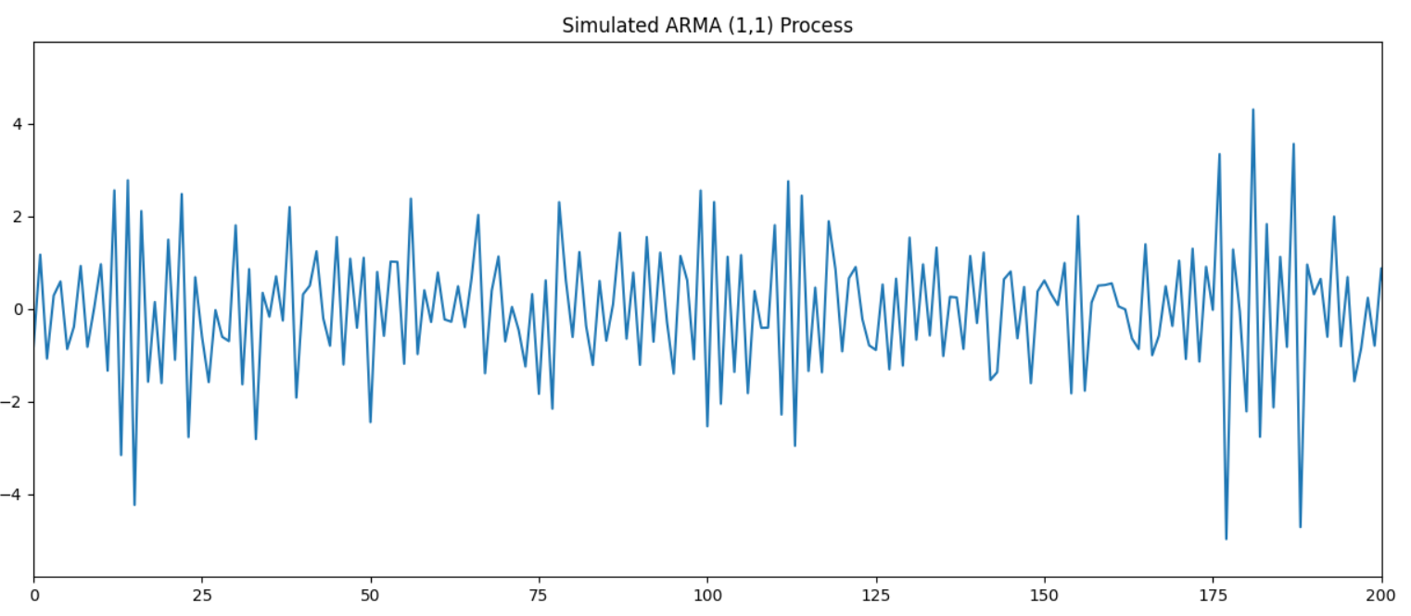
# Plotting ACF and PACF plots
plot_acf(simulated_ARMA_1_1_points);
plot_pacf(simulated_ARMA_1_1_points);

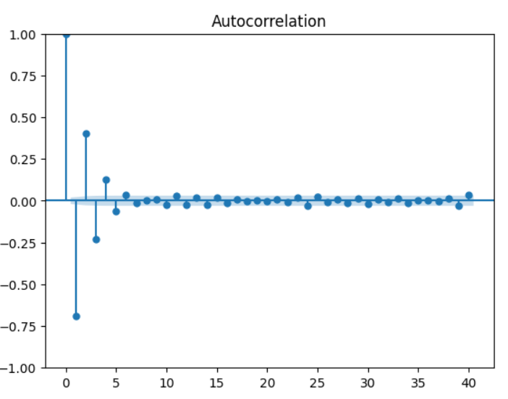
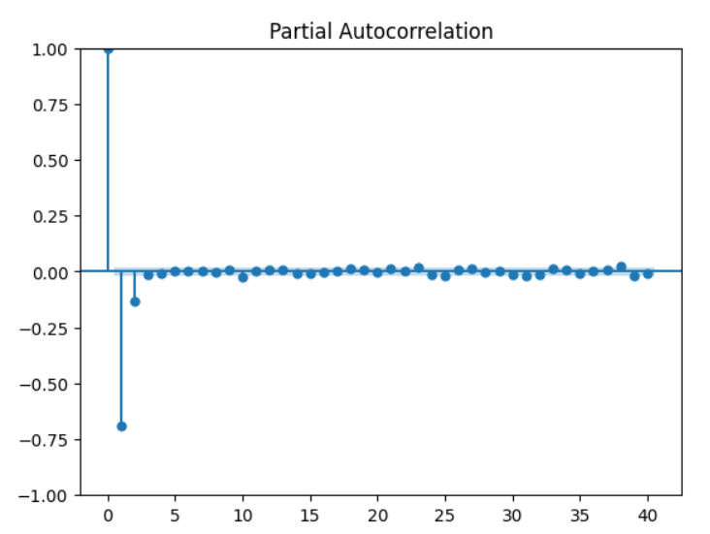
ar2 = np.array([1, 0.6, 0.4])
ma2 = np.array([1, -0.2, -0.5])

simulated_ARMA_2_2_points = ArmaProcess(ar2, ma2).generate_sample(nsample=10000)

plt.figure(figsize=[15,6]); # Set dimensions for figure
plt.plot(simulated_ARMA_2_2_points)
plt.title("Simulated ARMA (2,2) Process")
plt.xlim([0, 200])
plt.show()

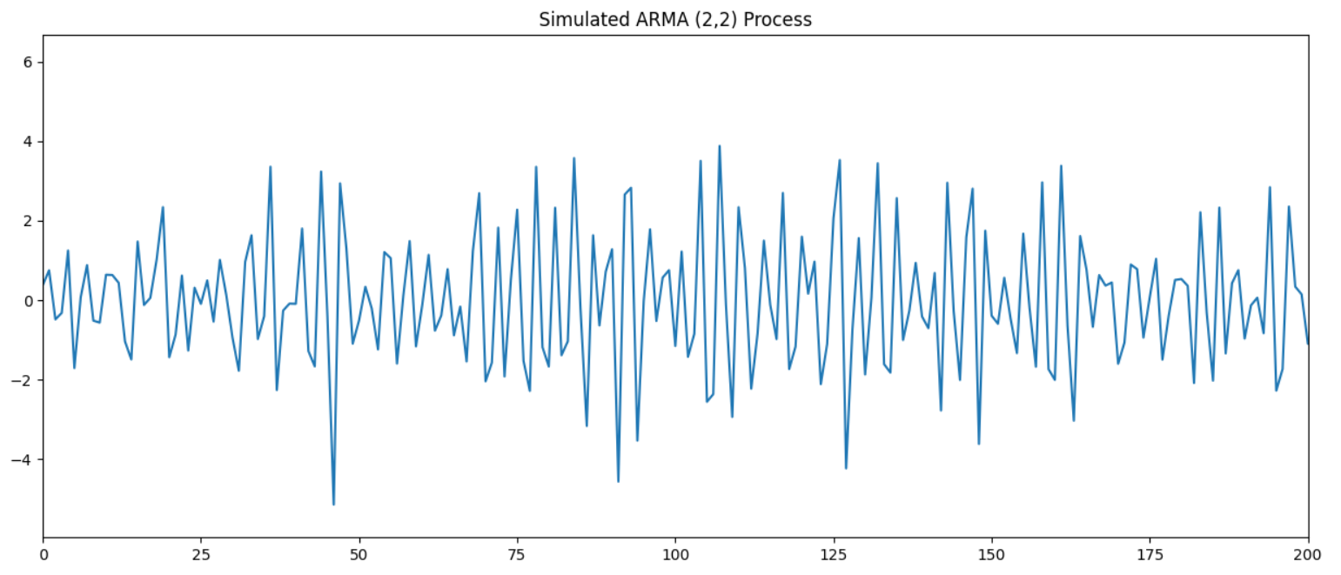

# Plotting ACF and PACF plots
plot_acf(simulated_ARMA_2_2_points);
plot_pacf(simulated_ARMA_2_2_points);
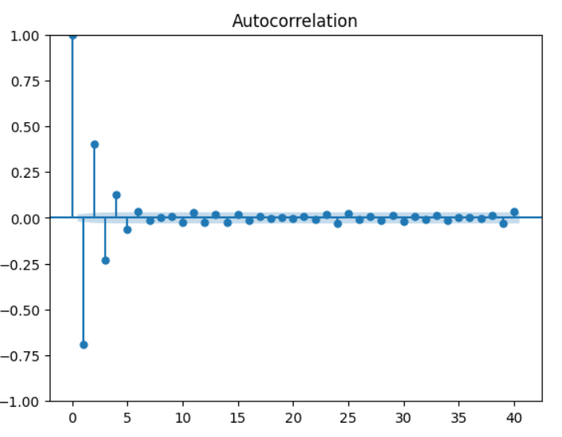
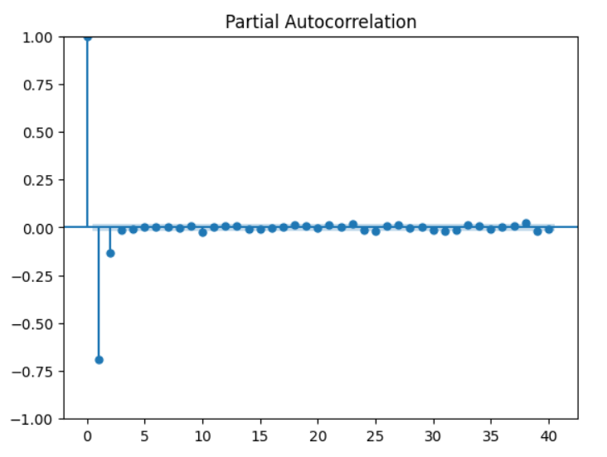

ar3 = np.array([1, 0.6, 0.4, 0.3])
ma3 = np.array([1, -0.2, -0.5, -0.5])

simulated_ARMA_3_3_points = ArmaProcess(ar2, ma2).generate_sample(nsample=10000)

plt.figure(figsize=[15,6]); # Set dimensions for figure
plt.plot(simulated_ARMA_3_3_points)
plt.title("Simulated ARMA (3,3) Process")
plt.xlim([0, 200])
plt.show()

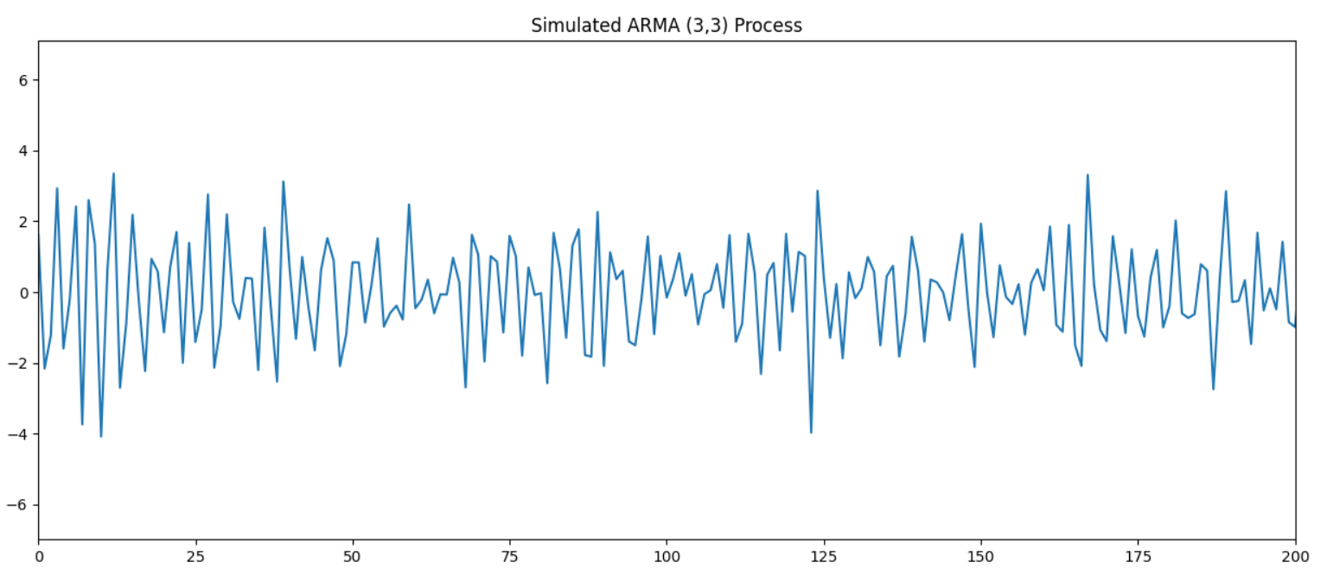
# Plotting ACF and PACF plots
plot_acf(simulated_ARMA_3_3_points);
plot_pacf(simulated_ARMA_3_3_points);

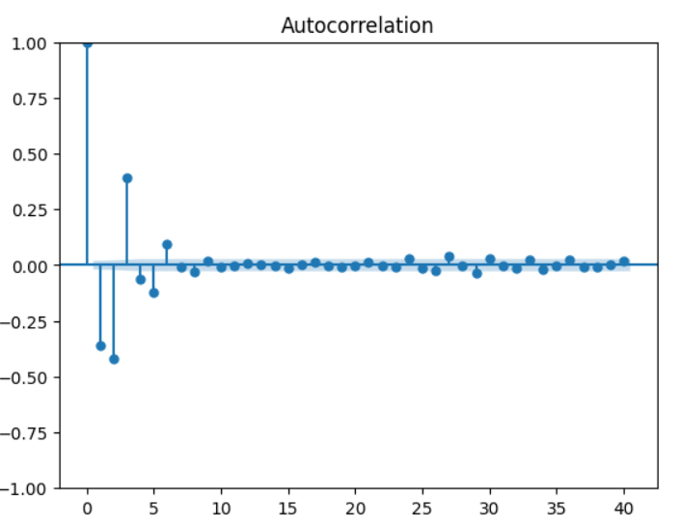
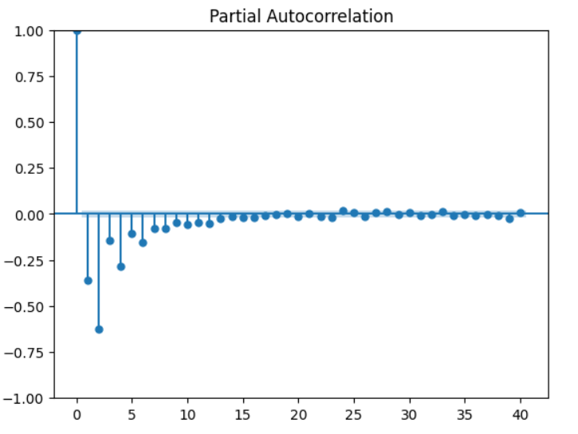

Autoregressive Integrated Moving Average Models (ARIMA Models)
This model is the combination of autoregression, a moving average model and differencing. In this context, integration is the opposite of differentiation. Differentiation is useful to remove the trend in a time series and make it stationary.
It simply involves subtracting a point a t-1 from time t.
Mathematically, the ARIMA(p,d,q) now requires three parameters:
1. p: the order of the autoregressive process
2. d: the degree of differentiation (number of times it was differenced)
3. q: the order of the moving average process

np.random.seed(200)

ar_params = np.array([1, -0.4])
ma_params = np.array([1, -0.8])

returns = ArmaProcess(ar_params, ma_params).generate_sample(nsample=1000)
returns = pd.Series(returns)
drift = 100

price = pd.Series(np.cumsum(returns)) + drift

returns.plot(figsize=(15,6), title="Simulated Return series")
plt.show()

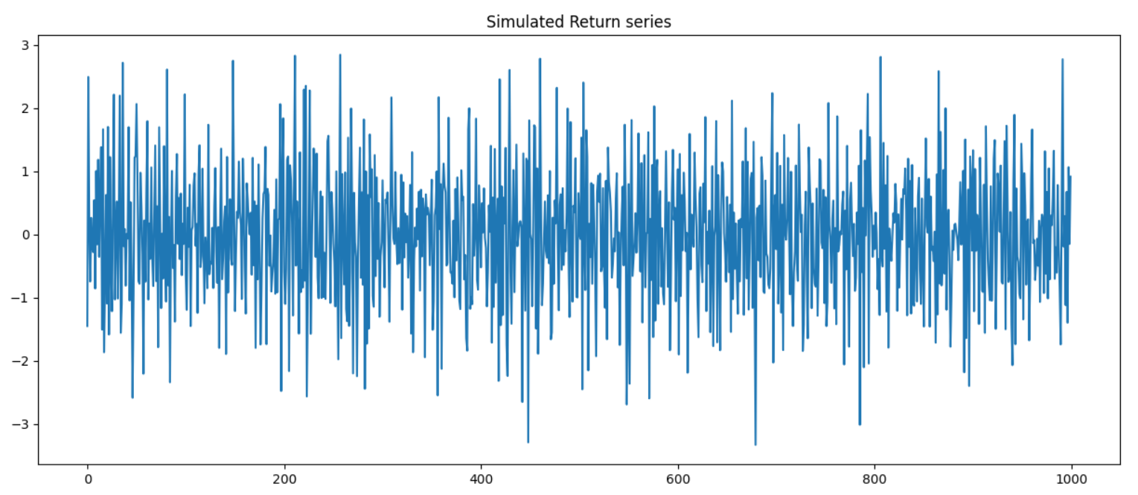
price.plot(figsize=(15,6), title="Simulated Price Series")
plt.show()

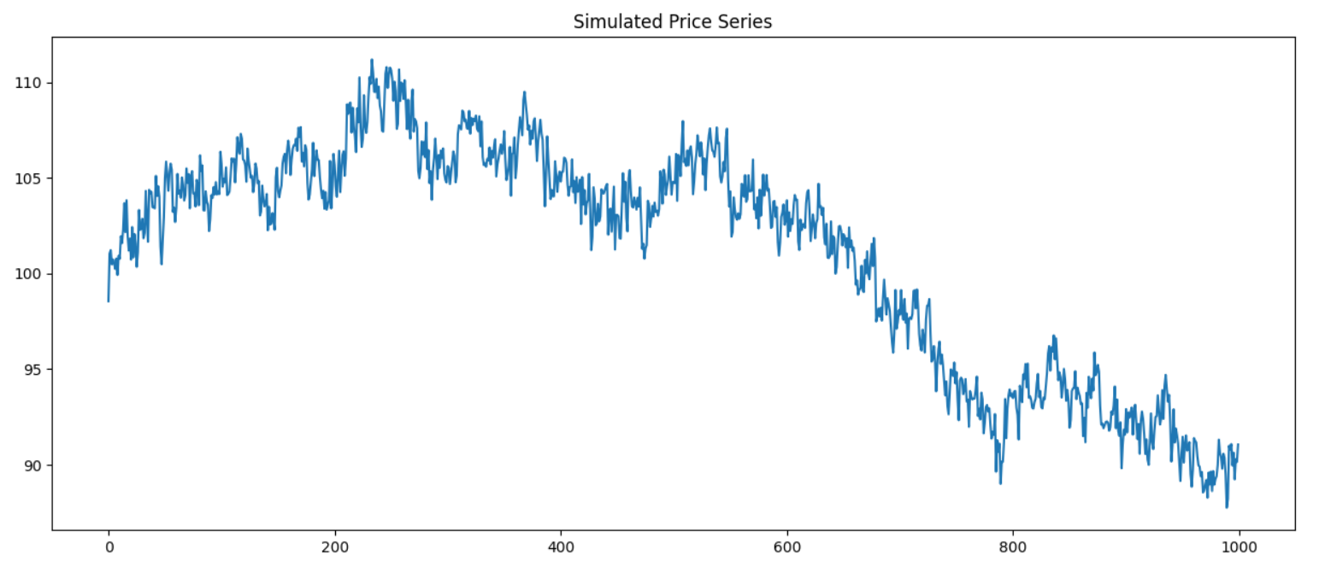

Conclusion:
We have successfully completed and implemented the code for ARMA and ARIMA model in time series data.

